*Team BAMF: LeAnne Sevier, Luciana Roberts, Lillian Bolfer, Mike Machata, Rob Phillips*

*AIRPORT DELAYS DURING GOVERNMENT SHUTDOWN*

The recent government shutdown during the period of December 22nd 2018 through January 25th 2019 impacted airlines and airport operations.

What evidence is there that airports or airlines experienced significant delays?

What can we learn from an analysis of data available on flight delays?



*Finding Data*

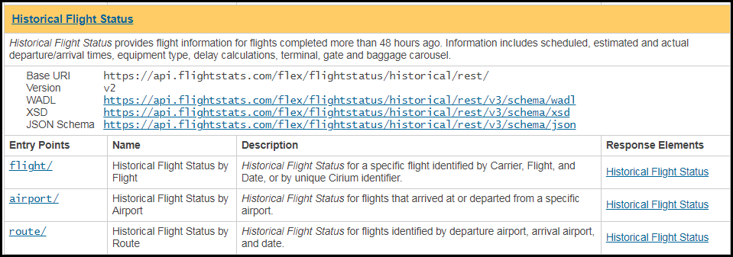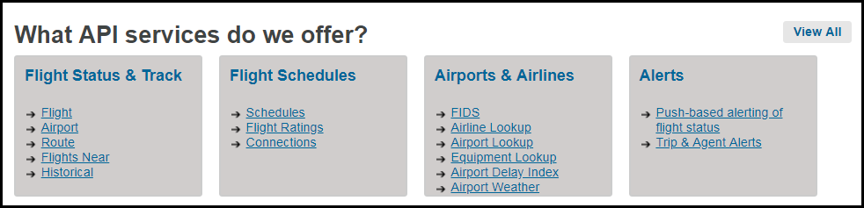

* Cirium Flightstats Developer Center – a commercial provider of global flight data through analysis and API services
  + Access to real-time and historical information used by mobile developers, airports, travel agencies, airlines and more
  + BUYER BEWARE! Although easy to obtain and digest, the API services are not all free! Historical data is an example!
  + BUT, we were able to connect to the API to collect for the specific timeframes, airports, and airline we needed, extracting the data in JSON format

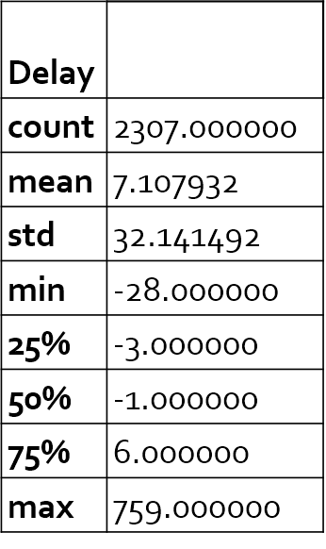

*Analysis process – At a glance!*

**Total Departures:** 2307

Flight Counter: 2307

Airline Flight#: DL2601

Airport: MCO

Date: 2018-01-25

Scheduled Departure: 2018-01-25T19:56:00.000 Actual Departure: 2018-01-25T19:50:00.000 Flight Departed Early by (H:M:S): 0:06:00 Departure Time Delta (minutes): -6.0

Flight Counter: 1

Airline Flight#: DL656

Airport: ATL

Date: 2017-12-22

Scheduled Departure: 2017-12-22T10:55:00.000 Actual Departure: 2017-12-22T16:51:00.000 Flight Departure Delayed by (H:M:S): 5:56:00 Departure Time Delta (minutes): 356.0

*Analysis process – At a glance!*

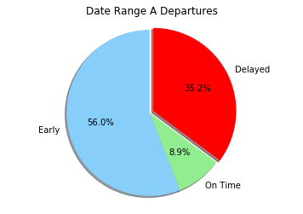

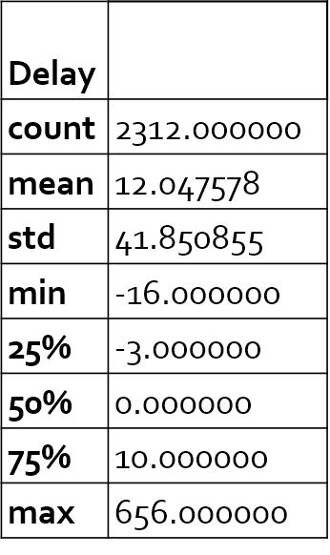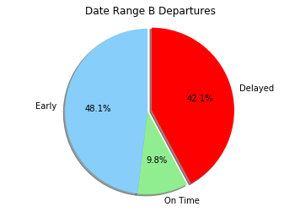

Flight Counter: 1

Airline Flight#: DL365

Airport: ATL

Date: 2018-12-22

Scheduled Departure: 2018-12-22T12:20:00.000 Actual Departure: 2018-12-22T16:37:00.000 Flight Departure Delayed by (H:M:S): 4:17:00 Departure Time Delta (minutes): 257.0

Total Departures: 2312

Flight Counter: 2312

Airline Flight#: DL1060

Airport: MCO

Date: 2019-01-25

Scheduled Departure: 2019-01-25T19:59:00.000 Actual Departure: 2019-01-25T20:33:00.000 Flight Departure Delayed by (H:M:S): 0:34:00 Departure Time Delta (minutes): 34.0

*Analysis process – At a glance!*

*So what’s the diff?   
Look at the Final Weeks*

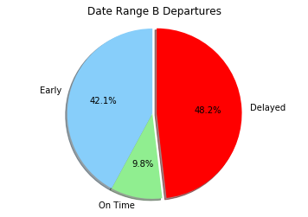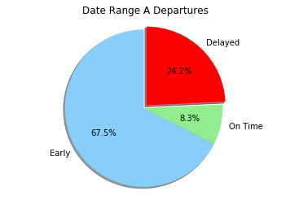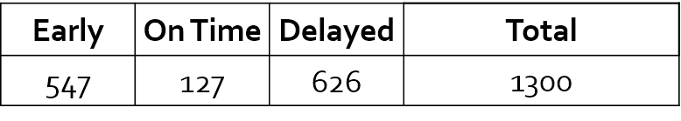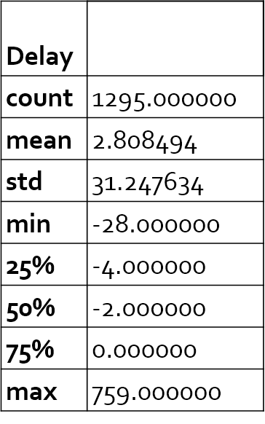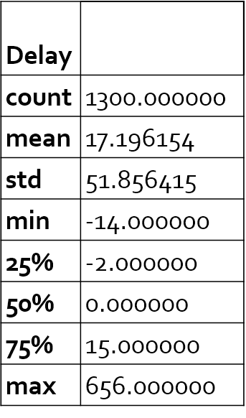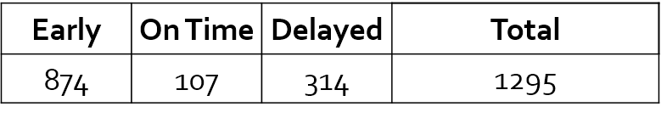

*Findings and conclusions*

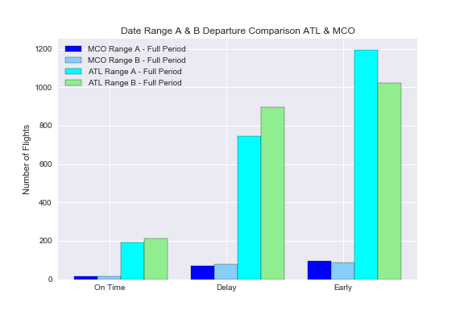

In the date range A, MCO airport has handled less than 8.5 % of the Delta flights comparing with the numbers of Delta flights in ATL airport. Even that MCO airport shows a higher proportional number of delayed departure flights.

In the shutdown period (range B) this difference has increased, showing that even operating a much higher number of flights, Atlanta airport has had a smaller impact with the shutdown than Orlando airport, when it comes to flight departures delays.

*Findings and conclusions*

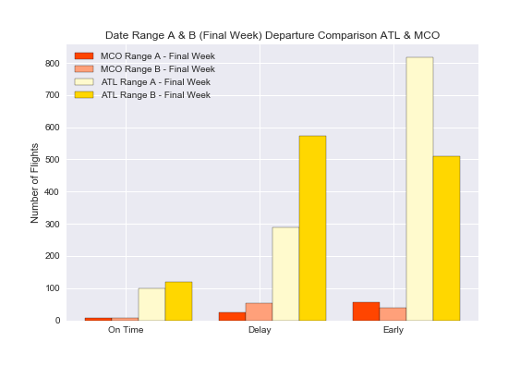

In the last week of the shutdown, the number of delayed departure flights has increased, representing over half of total delays for full shutdown period. (MCO full period 79, 52 in the last week – ATL full period 895, 574 in the last week) The increase might be related with TSA sickouts reaching 10% on Jan 20, 2019.

https://www.forbes.com/sites/michaelgoldstein/2019/01/22/us-airlines-take-stock-market-hit-as-government-shutdown-reaches-32-days/#68ff706a79de

*Findings and conclusions*

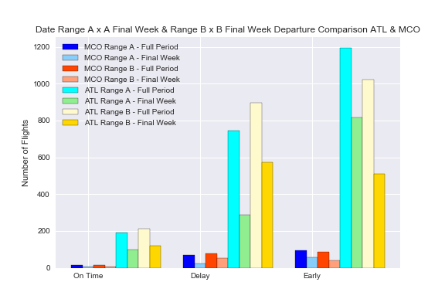

Comparing the numbers of flights in each date range per airport, we can conclude that MCO airport has being more affected by the shutdown in number of flights departure delays, than Atlanta airport, however, in the subject “delays” historically MCO airport has been behind ATL airport .

The MCO average delays for customs/security is 24,45 min. against 12,27 in ATL airport.

The average departures delays in MCO is 68 min. against 58 in ATL.

Atlanta Airport has a Delay Index of B – (401,78) and MCO Delay Index is D (517,80).

Based on these numbers we can assume that ATL airport was better prepared to deal with the shutdown than MCO airport.

https://www.orlandoweekly.com/Blogs/archives/2018/11/21/orlando-international-airport-ranked-among-most-likely-to-delay-your-flight

*Findings and conclusions*

AIRPORT TO AIRPORT IMPACT ANALYSIS

Q: What evidence is there that delays at one airport cause delays at another airport?

Based on the data we collected, we decided to examine any possible causality of delay from MCO to ATL and vice versa.



Acording to our data queries, only 4.8% (14+16) /( 574+52) of delayed flights out of ATL and MCO were bound for the other airport. This implies that on average, delays incurred at one airport do not incur significant delays at the other airports. But each airport has a different volume of airline flights originating from other airports (both domestic and international).

While Atlanta only received a comparative 2.8% of its delayed flights from MCO, Orlando received a comparative 27% of its delayed flights from ATL. So what does the data reveal for each airport?

*Findings and conclusions*

ORLANDO AIRPORT: The most significant ATL bound flight delays occurred on January 23rd where all but two of the eight delayed flights greatly exceeded mean delay durations of 12 (Range B) and 17 minutes (Range B Final Week).

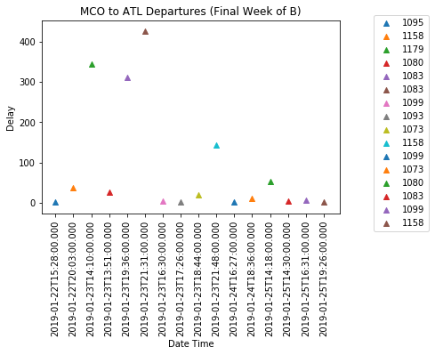

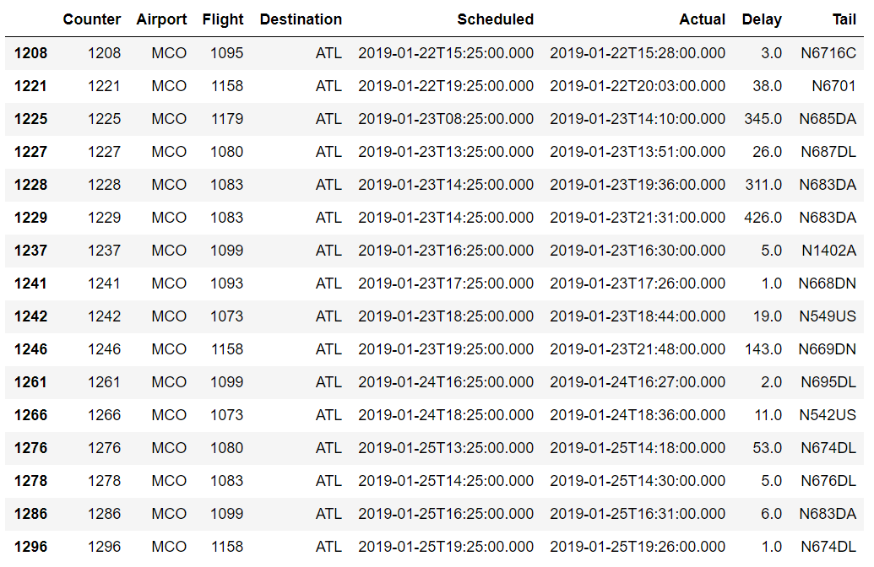

Flight 1083 / N683DA appeared to have particular difficulties with accumulative delays.

*Findings and conclusions*

**ATLANTA AIRPORT:** Considering ATL is a major hub (particularly for Delta Airlines), the mean delay for MCO bound aircraft is less than 15 minutes, which almost all fall within typical delay durations. While the 65 minute delay is outside our 8pm limit.

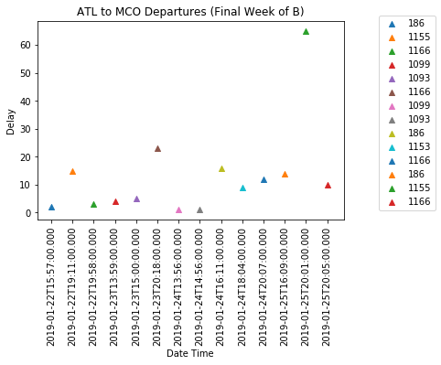

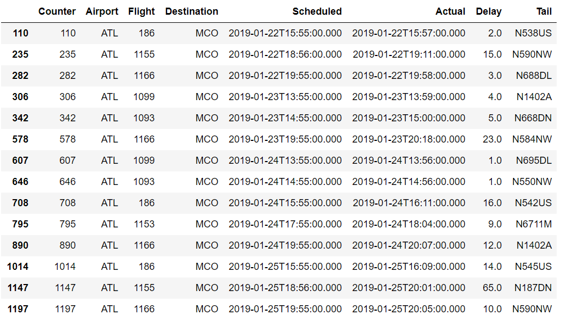

Based on the unique tail numbers, it appears that Delta utilizes a reserve of aircraft at ATL to operationally optimize for earliest possible departures.

*Summary*

* Watch Out! Data Analysts Beware! – Some API vendors charge by transaction (10 cents per flight)
* Government shutdown effects on airports and airlines is gradual. There was no significant disruption to the number of flights or passengers, and delay durations in the first week of shutdown was comparable to the non-government shutdown period.
* Delta Airlines appears to be able to operationally optimize aircraft at the Major Hub of Atlanta to reduce departures delay times. They are less dependent on specific aircraft making timely connections. But this does not imply that all passengers are always able to make their connections through Atlanta Airport.
* Delayed flights bound for Atlanta from Orlando experience significantly larger delays compared with connections in Atlanta. This might be due to lower availability of air traffic controllers at MCO compared with ATL. It may also be due to the volume of passengers originating in Orlando, unable to board timely, due to extensive security checkpoint delays.
* If the government elects to privatize air traffic controllers and airport security and customs officers, this might possibly alleviate some of the airport based flight delays. But there is insufficient data available to directly correlate all of these factors.
* If I do need to travel during a government shutdown in the future, I would plan to book a morning flight from Orlando, with enough time to make an afternoon connection in Atlanta. I would be less concerned with my connection being delayed in Atlanta.